YEAR 11 – UNIT 1 EXAM - 2020

COMMENTS, ANALYSIS and

SAMPLE ANSWERS

STATISTICS

OVERALL AVERAGE | 65%
HIGHEST OVERALL MARK | 92%
SECTION ONE: Multiple Choice: AVERAGE | 69%
SECTION TWO: Data Interpretation: AVERAGE | 65%
SECTION THREE: Extended Answer: AVERAGE | 63%

Overall Comments:

- Overall a solid performance by the cohort. However, there is plenty of room for improvement by many.
- Read the questions VERY carefully!!! STOP AND THINK ABOUT EACH QUESTION, DON’T DIVE IN TOO QUICKLY. For full marks you need to answer all parts of the question. This pause time will help you think through your response.
- Only respond to what the question asks of you, not what you would like it to ask.
- Highlight key parts of each question – directives and main concepts.
- Sophisticated and detailed responses earn the highest marks, superficial responses lacking in detail earn low marks even if on the right track.
- Answers that are theoretically perfect but don’t answer the question earn 0 marks.
- Many students giving correct main point but explanation is confused and offers poor analysis.
- USE THE DATA in your responses.
STUDY – it is critical to gain understanding in economics, wrote learning will only take you so far. How do you do this?
- Teach the bedroom wall, teach your parents, teach each other
- Visual notetaking
- Mind maps, then condensed mind maps, then further condensed mind maps. Get it down to one page for each section
- Stare at the ceiling, put the pieces together
- Practice makes perfect

TIPS FOR MC SECTION

Multiple-choice questions tend to test your understanding of:

- Definitions – your knowledge of key terms
- Relationships – the linkages between two or more economic concepts
- Facts - knowledge of recent trends in the economy
- Calculations – to undertake a simple calculation based on data provided
- Making a conclusion based on data supplied

Answer strategy

- Read the stem of the question and put it in your own words
- Work out what it is asking for (e.g. knowledge of a fact or relationship etc.)
- Eliminate the ones that are incorrect
- Make a choice then go back over the stem to check it makes sense

Advice for students
- Don’t rush ! Take your time - too often students rush the Multiple Choice section aiming to add to their writing time but make simple mistakes as a result.
- Often it’s NOT the most obvious answer, if you delve into question properly there may be a better answer
- You are looking for the most correct answer – often there are more than one correct answers!
- Easy to get a mark, easy to lose a mark



SECTION ONE - Multiple Choice 24 marks (24%)

- Which one of these is a function of a competitive market?
(a) Maintaining stable prices between different markets
(b) Eliminating shortages of goods by allowing market prices to fall
(c) Achieving an equitable distribution of scarce resources
(d) Providing incentives for firms to provide goods to make a profit

- What is consistent with an individual demand curve that slopes down from left to right?
(a) As price falls, a person switches away from substitute products towards the product
(b) As price falls, a person’s willingness and ability to buy the product will decline
(c) As price rises, a person becomes less sensitive to price changes
(d) As price rises, a person’s opportunity cost of purchasing the product falls

- The effect of a rise in the price of a substitute good Y on the market for good X will be to

(a) Shift the demand curve left and decrease the equilibrium price
(b) Shift the demand curve right and increase the equilibrium price
(c) Shift the supply curve left and increase the equilibrium price
(d) Shift the supply curve right and decrease the equilibrium price

- Which one of the following would result in a higher quantity consumed and a lower price charged for tomatoes?
(a) A fall in the price of the fertilizer used to grow tomatoes
(b) A hot summer causes consumers to eat more tomato salad
(c) The minimum wage for farm workers is increased
(d) The price of cucumbers rises

- What will be the impact on the market for oil of the closure of the world’s largest oil field for maintenance work?
(a) A movement down the supply curve
(b) A movement up the demand curve
(c) A shift of the demand curve to the left
(d) A shift of the supply curve to the right

- A recent news story reported that OPEC is expected to decrease the supply of oil next summer. Summer is traditionally a time of increased demand for oil because of the many families driving and flying to vacation sites. What would be the combined effect of these two activities on the summer market for gasoline?

- An increase in the equilibrium price and the quantity
- An increase in the equilibrium price and an unpredictable change in the equilibrium quantity
- An unpredictable change in both the equilibrium price and the quantity
- An unpredictable change in the equilibrium price and a decrease in the equilibrium quantity

- In which situation is the demand for a product said to be price elastic?
(a) A fall in price increases quantity demanded
(b) A fall in price increases consumer expenditure on the product
(c) A rise in price increases consumer expenditure on the product
(d) A rise in price reduces quantity demanded

Price | Quantity demanded
$5.00 | 400
$4.50 | 480
- The table shows the demand for chocolates at two different prices. What is the price elasticity of demand when the price falls from $5.00 to $4.50?

(a) Less than 0.5
(b) Between 0.5 and 1
(c) Between 1 and 1.5
(d) Greater than 1.5

- A product has a price elasticity of supply of 2.0. A change in price causes the quantity supplied to change from 100 units to 120 units. What is the price change?
(a) A fall of 10%
(b) A fall of 40%
(c) A rise of 10%
(d) A rise of 40%

- If goods X and Y are complements, which of the following could be the value of cross price elasticity of demand?

(a) 0
(b) 1
(c) -1
(d) All of the above could be the value of cross price elasticity of demand

- What follows if the income elasticity of demand for a good has a value of – 0.2?
(a) When income rises less of the good is bought
(b) When income rises more of the good is bought
(c) When price falls more of the good is bought
(d) When price rises less of the good is bought

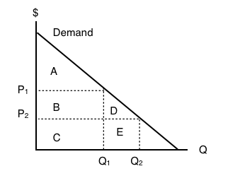
- The following question refers to the diagram below, which illustrates an individual’s demand curve for a good.

If the price of this good falls from P₁ to P₂, then consumer surplus will _____ by areas_____

(a) Increase; B+D
(b) Decrease; B+D
(c) Increase; A+B+D
(d) Decrease; A

- Sarah is selling her used truck. The minimum amount she needs to be paid for the truck is $5,000. She advertises the truck on a used cars website for $8,000, and eventually sells the truck for $6,000. Her surplus is a

(a) Producer surplus that is equal to $1000
(b) Consumer surplus that is equal to $1000
(c) Producer surplus that is equal to $2000
(d) Consumer surplus that is equal to $2000

- The diagram shows the market for diesel fuel. The demand for diesel fuel decreases from D1 to D2. Which area represents the new producer surplus for companies supplying diesel fuel?
(a) GMNH
(b) JGM
(c) JHN
(d) JNR

- If the government removes a price ceiling from a market, then the price paid by buyers will

(a) Increase and the quantity bought and sold in the market will increase
(b) Increase and the quantity bought and sold in the market will decrease
(c) Decrease and the quantity bought and sold in the market will increase
(d) Decrease and the quantity bought and sold in the market will decrease

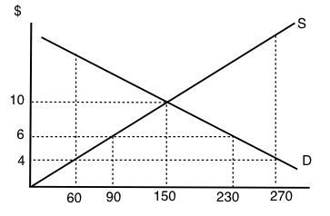
- Consider the supply and demand curve diagram below.
If the maximum price set for this good is $6, then:

(a) There is an excess demand (a shortage) equal to 210 units
(b) There is an excess demand (a shortage) equal to 140 units
(c) There is an excess supply (a surplus) equal to 210 units
(d) There is an excess supply (a surplus) equal to 140 units

- Which of these is an example of market failure?
(a) A general increase in the price of hotel rooms in busy summer seasons
(b) An increase in house prices caused by easier borrowing for house buyers
(c) An increase in travel time caused by a road accident
(d) An increase in unsold goods because of a change in tastes

- Which situation involving the building industry is most likely to be investigated by the ACCC to control restrictive practices?
(a) A builder purchasing a plot of land for development of housing
(b) Groups of suppliers of building materials agreeing to fix prices
(c) Several builders bidding for the same contracts
(d) Several builders using different sources of supply

- An airline upgrades its services by providing a bigger aircraft. The airline claims it will reduce both travel time and carbon emissions per passenger journey although fares may rise. What is a private cost and an external benefit of this decision?

 | Private cost | External benefit
(a) | Less carbon emissions | Reduced travel time
(b) | Increased fuel costs | Less carbon emissions
(c) | Reduced travel time | Bigger aircraft
(d) | Bigger aircraft | Higher fares

- In a market where the external costs of production are represented in the supply curve then:

(a) Market price would tend to be higher and the quantity traded higher
(b) Market price would tend to be higher and the quantity traded lower
(c) Market price would tend to be lower and the quantity traded lower
(d) Market price would tend to be lower and quantity traded higher

- Taxes __________ the price paid by the buyer and __________ the price received by the seller.

(a) Decrease, increase
(b) Decrease, decrease
(c) Increase, increase
(d) Increase, decrease

- Which of the following correctly describes the equilibrium effects of a per unit subsidy?

(a) Consumer price rises, producer price falls, and quantity increases
(b) Consumer price falls, producer price falls and quantity increases
(c) Consumer price rises, producer price rises, and quantity increases
(d) Consumer price falls, producer price rises, and quantity increases

- Public goods can be

(a) Provided privately
(b) Provided publicly
(c) Subject to free rider problems
(d) All of the above

- The WA Fisheries have reported a decline in fish stocks worldwide over the last decade. This is because ocean environments are

(a) Non-excludable and rival in consumption
(b) Excludable but non-rival in consumption
(c) Non-excludable and non-rival in consumption
(d) Excludable but rival in consumption

Section 2 36 marks (36%)

TIPS FOR DATA INTERPRETATION SECTION

- ‘Data interpretation’ means questions that use the data to answer
- Data will generally be either a graph, a table or an article.
- Data questions will be asking for comprehension of the data (1 and 2 mark questions), linking the data with theory (3 and 4 mark questions) and analysis (6 mark questions)
- Suggested approach as you work through each question:
  - Highlight key parts of the question
  - STOP and THINK – what is the Q asking of you
  - Study the data in relation to what the Q is asking (e.g. asking for the trade balance, look at this in more detail in the data)
    - IF TABLES AND CHARTS - What is the headline of the data ? What does each line/curve/bar represent? What trends can you discern from the data? What relationships are there between the variables shown? How can you use the data in your answer?
    - IF ITS AN ARTICLE – What is the headline? Underline key words and quotes. How can you use the quotes/statistics or examples from the article as part of your answer?
  - Respond to the question

Question 25 (12 marks)

Comments

- Good definitions were provided

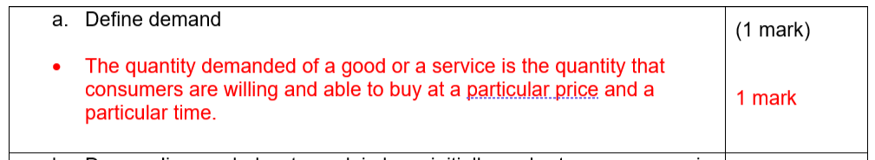

- Many students were drawing a shortage occurring as a result of a change in price. A non price factor caused the increase in demand therefore the demand curve must shift to the right.

Students were forgetting to mention that initially, supply remained a Q1.

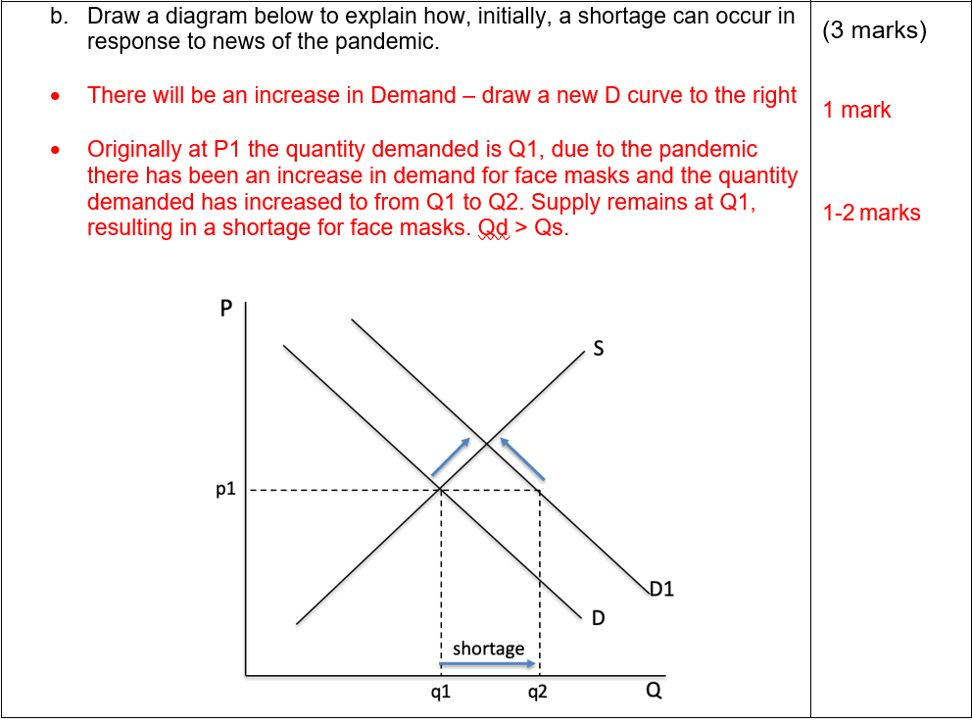

- Some students not using the correct terminology - must say supply EXPANDS and Demand CONTRACTS.

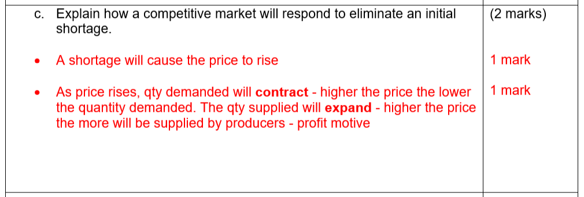

- Many students only said the demand would increase and failed to mention that this would result in a higher price.

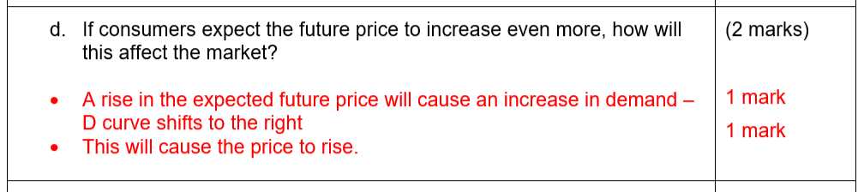

- Many students talked about a price floor or a price ceiling - a price floor is incorrect because this increases production but also increases prices. A price ceiling is incorrect because it increases demand but supply contracts.
- Some students forgetting to show the DWL - 1.5/2 marks
- Some students mixing up the CS and PS on the subsidy diagram

- The government wants to stimulate production and reduce prices for face masks. What policy could it introduce to achieve this? Show the impact on a diagram below. Would it increase market efficiency?  - Diagram – 2 marks: show an increase in supply – S curve shifts to the right causing equil. P to decrease & equil. Qty to increase.  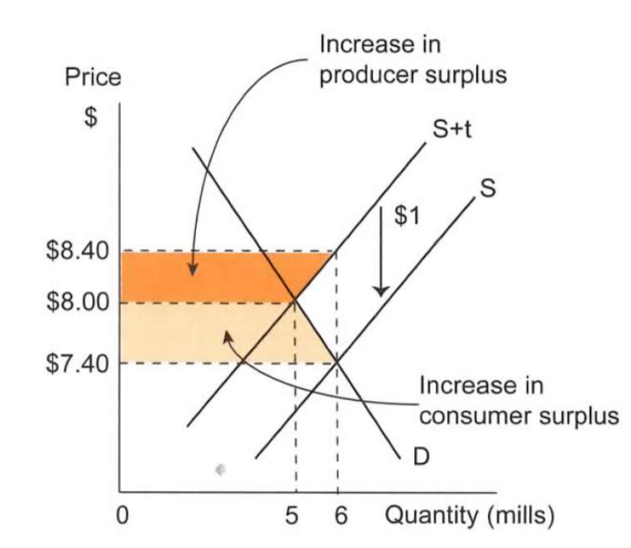  - The subsidy will cause the market price to decrease and the quantity to rise. There will be an increase in consumer surplus (they pay less and receive more) There will be an increase in producer surplus (they receive a higher price and sell a larger quantity)  - However, the increase in CS and PS is at a cost to the government. The cost to the government is greater than the combined increase in CS and PS. This means that the subsidy has created a DWL. Decrease in total economic welfare. | (4 marks)  1-2 marks  1 mark  1 mark

Sample Answer

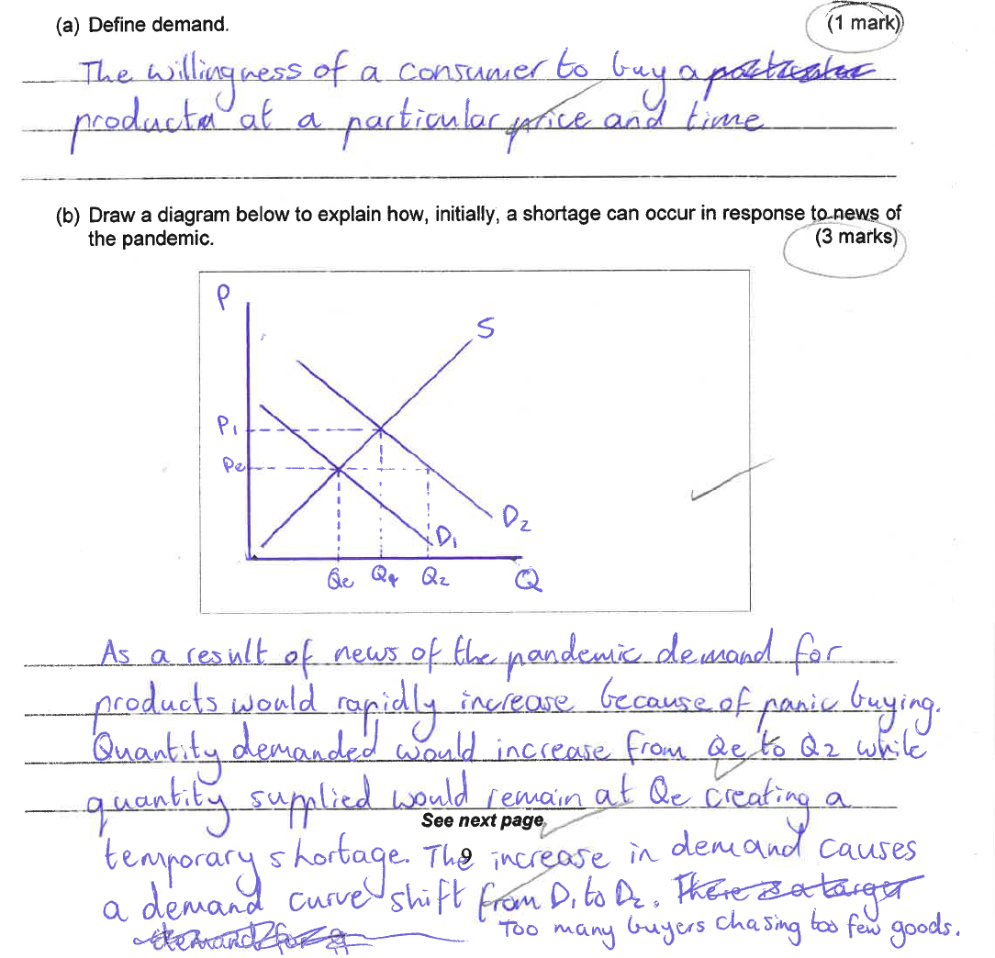

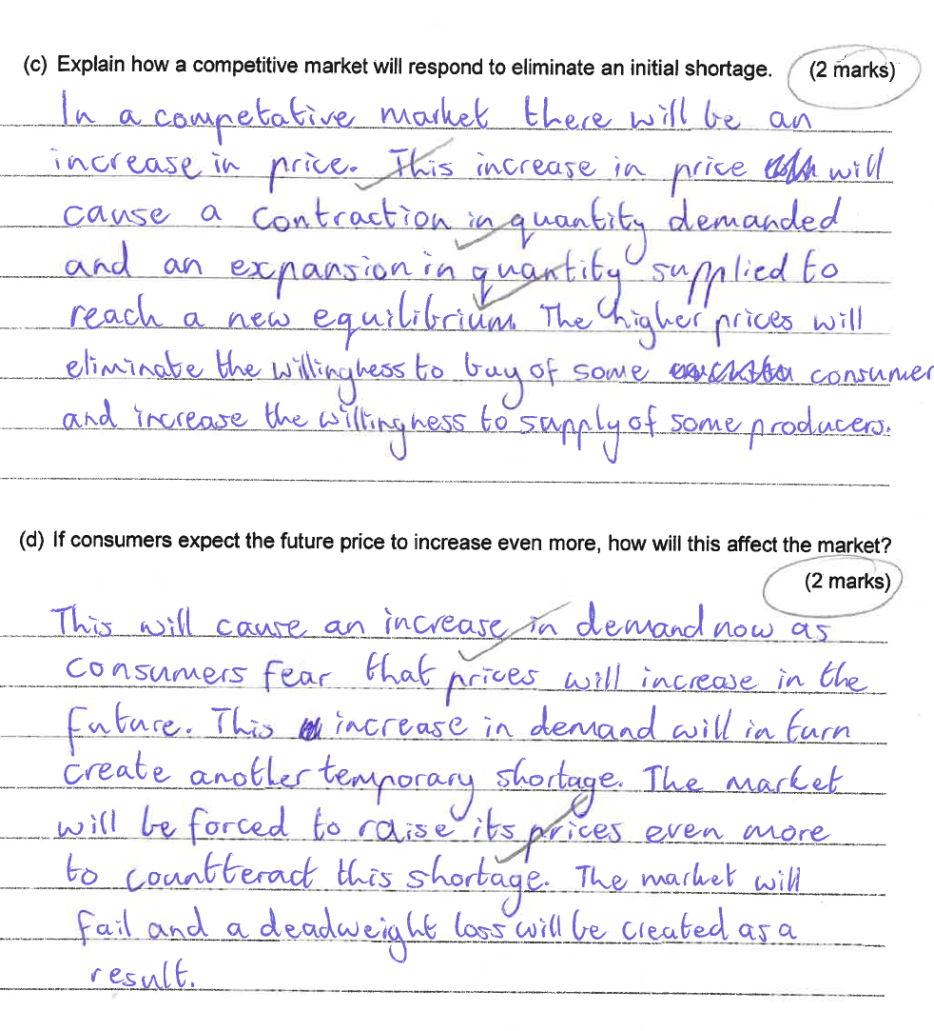

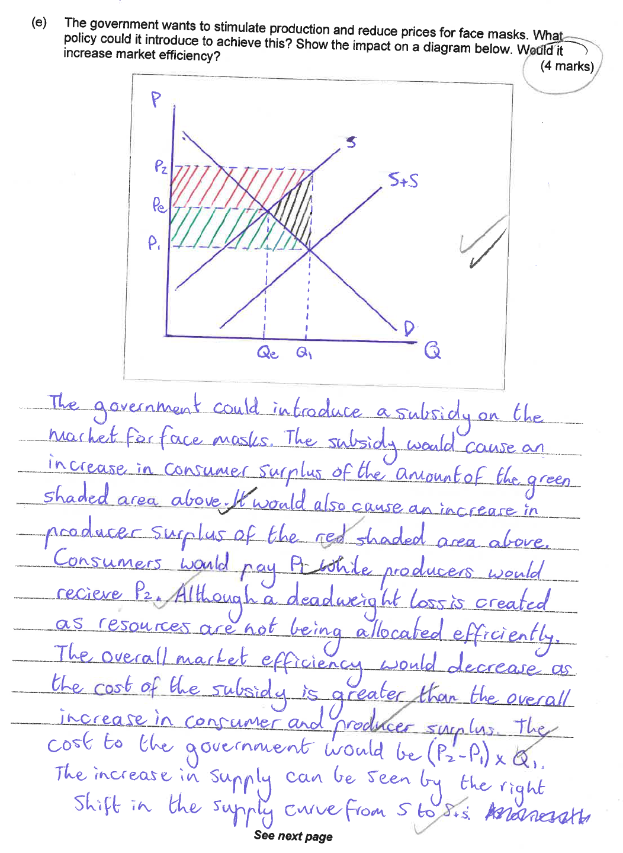

Question 26 (12 marks)

Comments

- Good definitions provided.
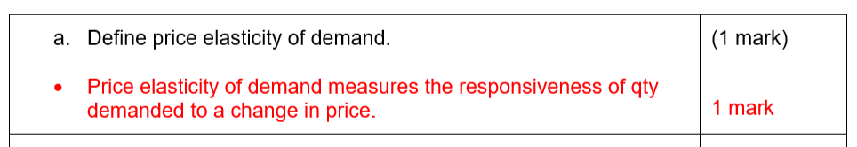
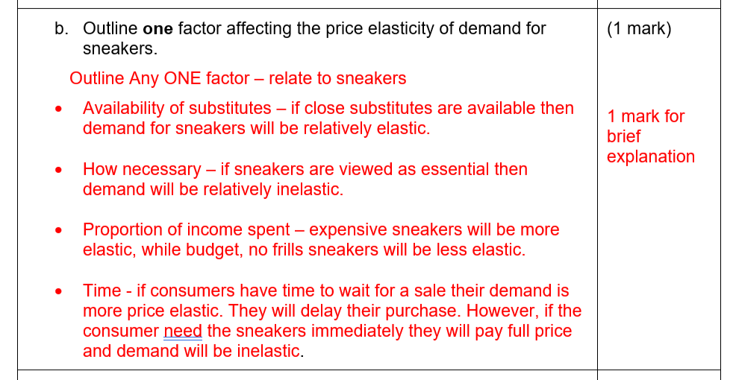
- Some students talked about the factors affecting demand rather than the factors affecting PED

- Some students struggled with the calculation

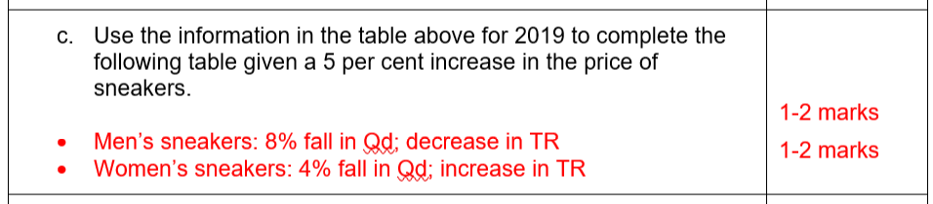

- Some students misinterpreted the question and discussed high income and low income earners. The customer group was referring to the data i.e. men v women.
- Those that interpreted the question correctly, many lost a mark by not supporting their answer with data.

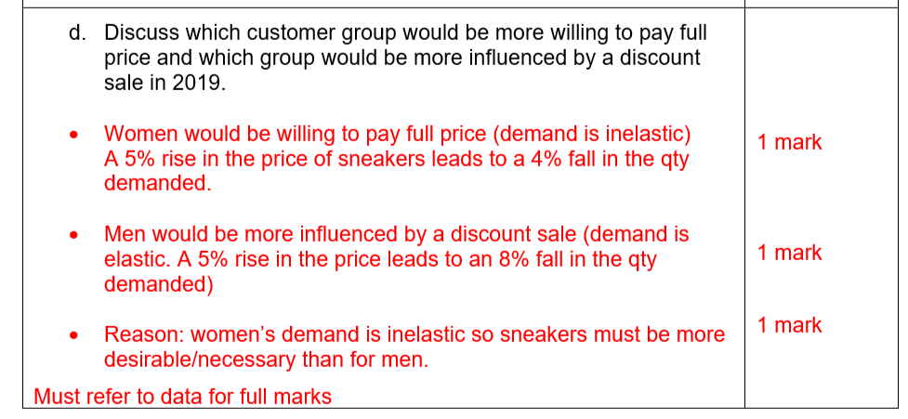

- This part was done well

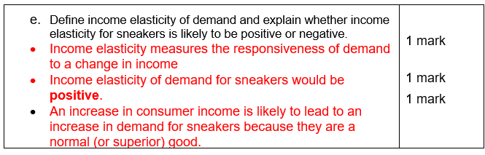

Sample Answer

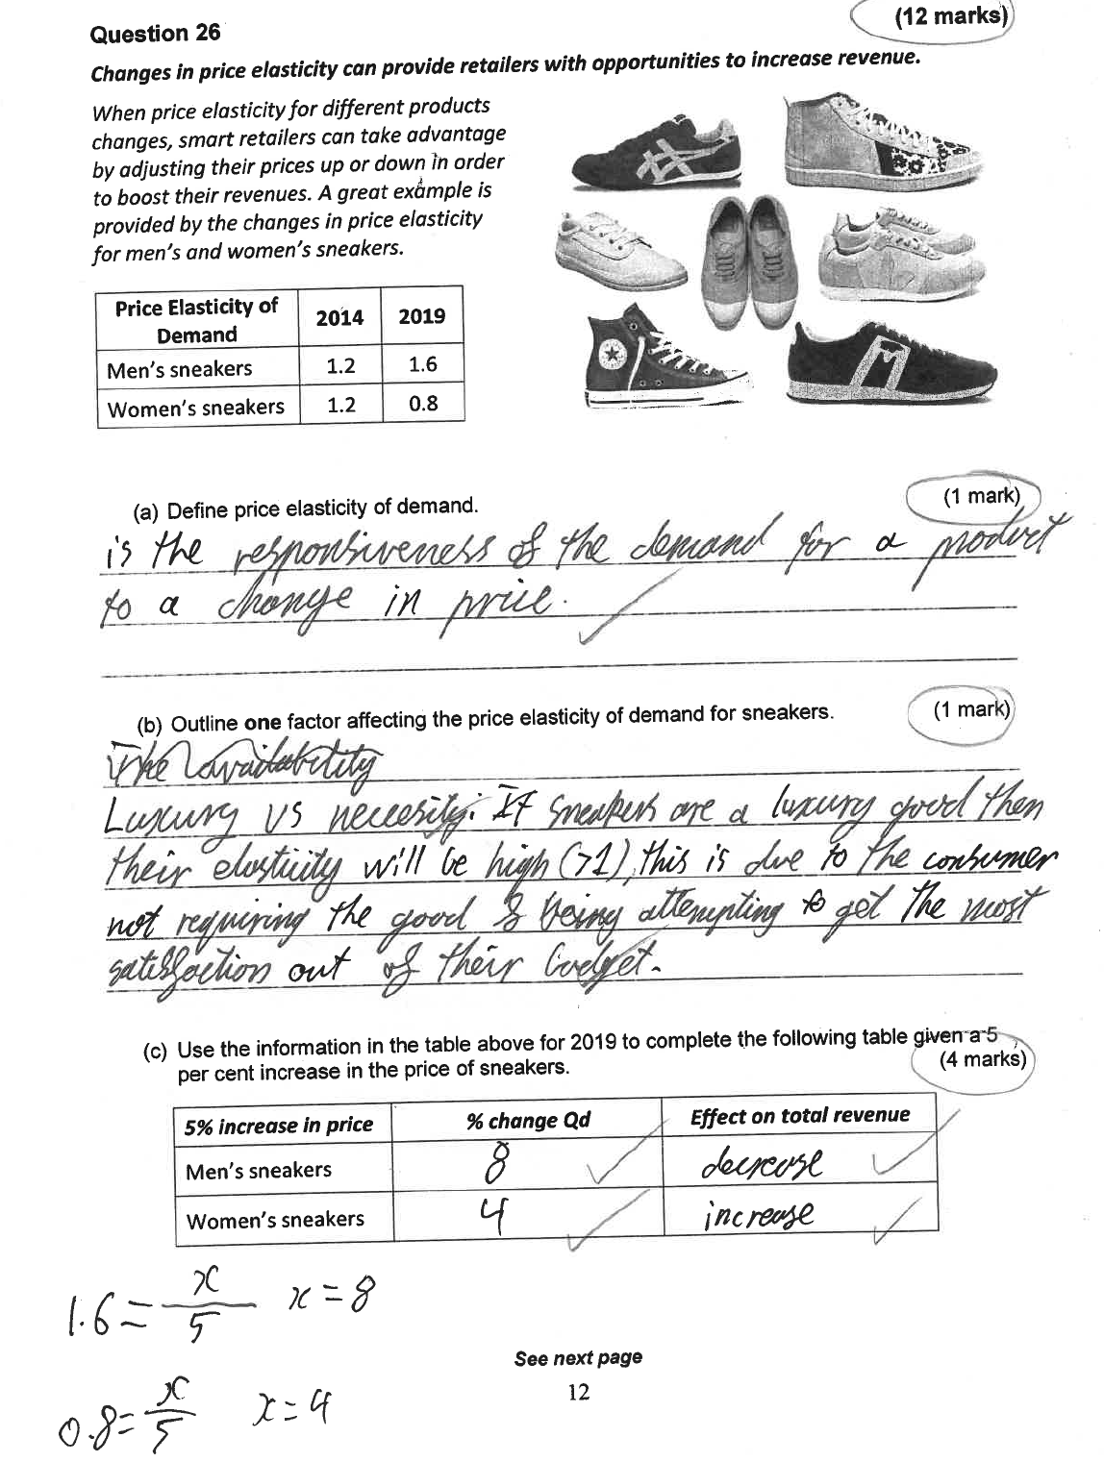

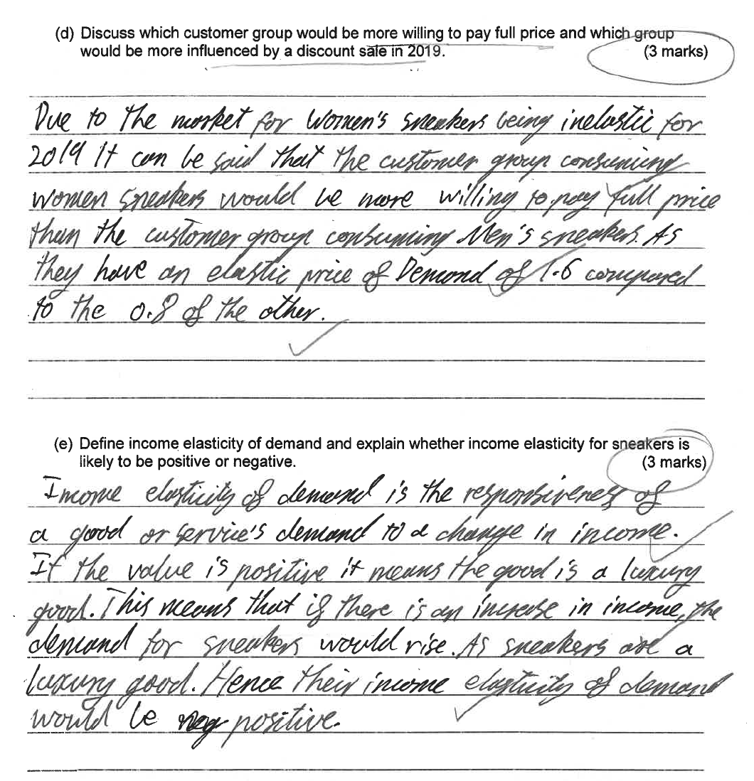

Question 27 (12 marks)

Comments
- Part a, b and e were generally answered well.
- Part c - some students repeating the question without answering it.
- Part d. some confused with which model to use. Lots of students shifting the supply curve rather than the demand curve. The question specifically stated that positive consumption externalitiy - the word consumption indicates that you shift the demand curve

- Define positive consumption externality.  - A positive externality exists if the consumption of a good or service benefits a third party not directly involved in the market transaction. | (1 mark)  1 mark
- Using examples, distinguish between a private benefit and an external benefit  - Private benefit: The rewards of an economic activity to individuals (consumers) or firms (producers) e.g. vaccinated against a disease.  - Social benefit: The benefit of an economic activity to society as well as to the individual or firm. E.g. herd immunity from vaccinations, they not only make people immune to a disease, but they will not pass on that disease to others, so the result will be a healthier population. This will also make people more productive. | (2 marks)  1 mark  1 mark
- Describe why the market for vaccines fails to produce at the socially optimal level of output.  - Some people don't understand how important vaccinations are, not just for the person getting them but for society. The private market fails to recognise the external benefits of vaccinations to society. (the difference between the private benefit and the social benefit)  - The market fails because it underproduces, the market quantity is less than the optimal quantity. This results in a deadweight loss. (loss in total surplus)  May also reference stimulus to support answer or other info from notes  - consumers seem much more willing to pay for treatment than for prevention.  - Vaccines for certain diseases are more expensive than others and some people cannot afford them, or they consider them over-priced and choose not to purchase them. | (2 marks)  (1 mark)  - marks)
- With the aid of a diagram, explain how the government could internalise the positive consumption externality of vaccinations using a subsidy.  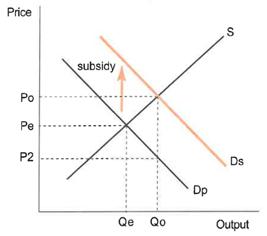  - Definition - a subsidy is a grant paid to producers with the purpose of reducing costs and increasing output.  - To internalise a positive externality the government can pay a subsidy to consumers equal to the external benefit. (the difference between the Dp and Ds)  - The subsidy is equal to P2 Po. The subsidy shifts the consumer's private demand curve (Dp) to the social demand curve (Ds)  - Producers receive Po but the consumers only pay P2 (after the subsidy) and the quantity is increased to Qo.  - The subsidy has reduced the price and increased the quantity consumed.  Must reference the model in answer for full marks | (6 marks)  1 mark  - marks  - - 3 marks
- Other than a subsidy, identify one policy option that could be effective at increasing the consumption of vaccinations.  - Education - the government could provide people with information about the importance of vaccinations and their benefits. This could help to increase the consumption of vaccines.  - Laws the government could make laws that say citizens must be vaccinated against certain diseases.  - Advertisements would be a good way of educating people, if it reaches a wide audience.  - Direct government provision | (1 mark)  1 mark

Sample Answer

See next page
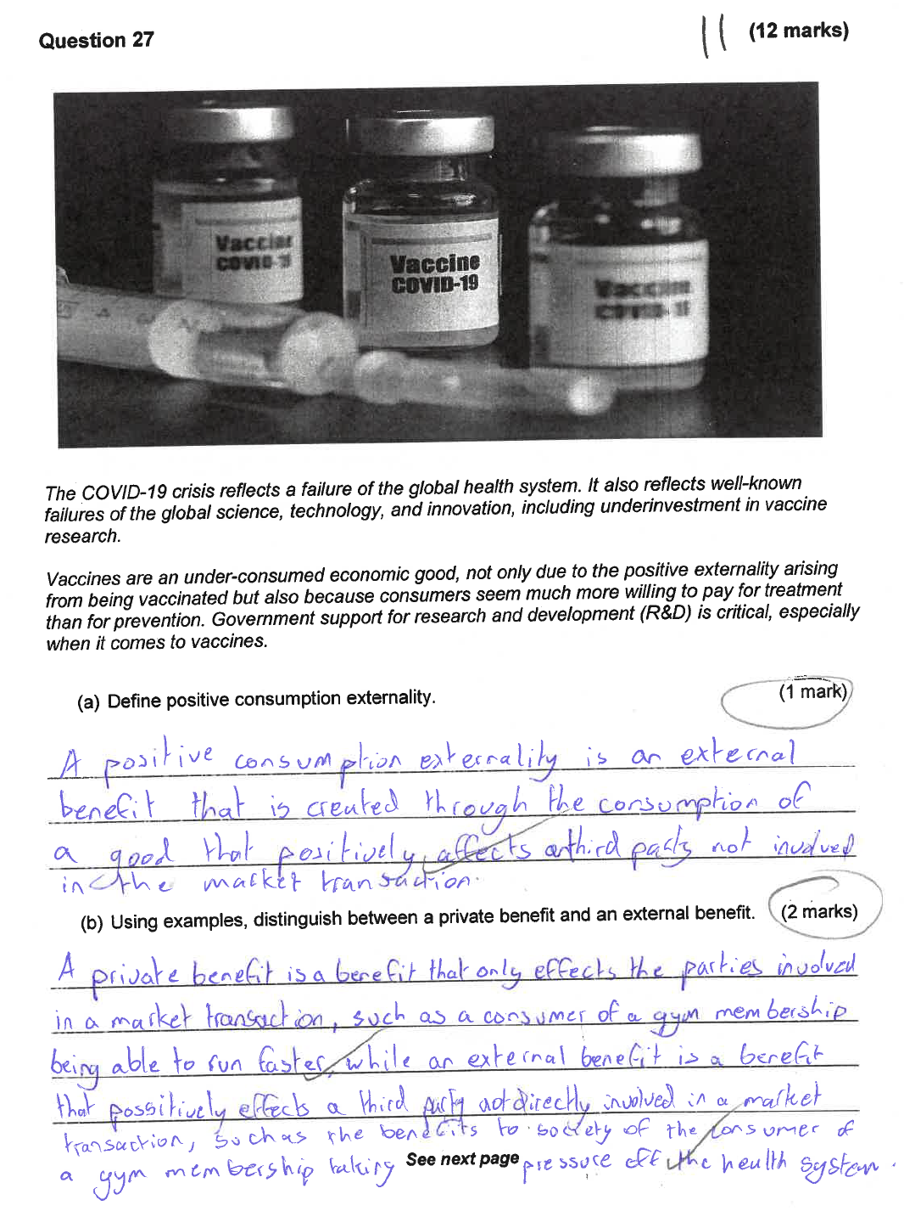

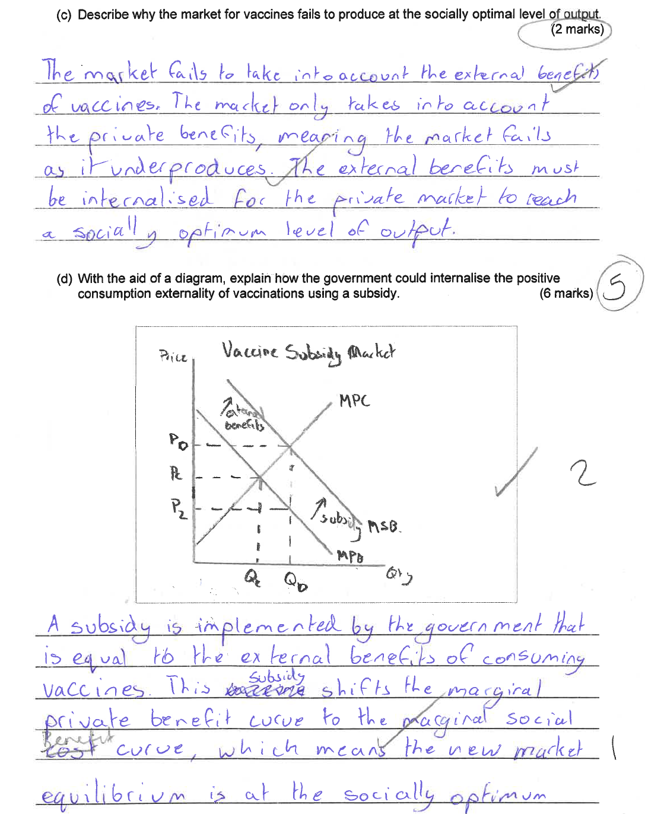
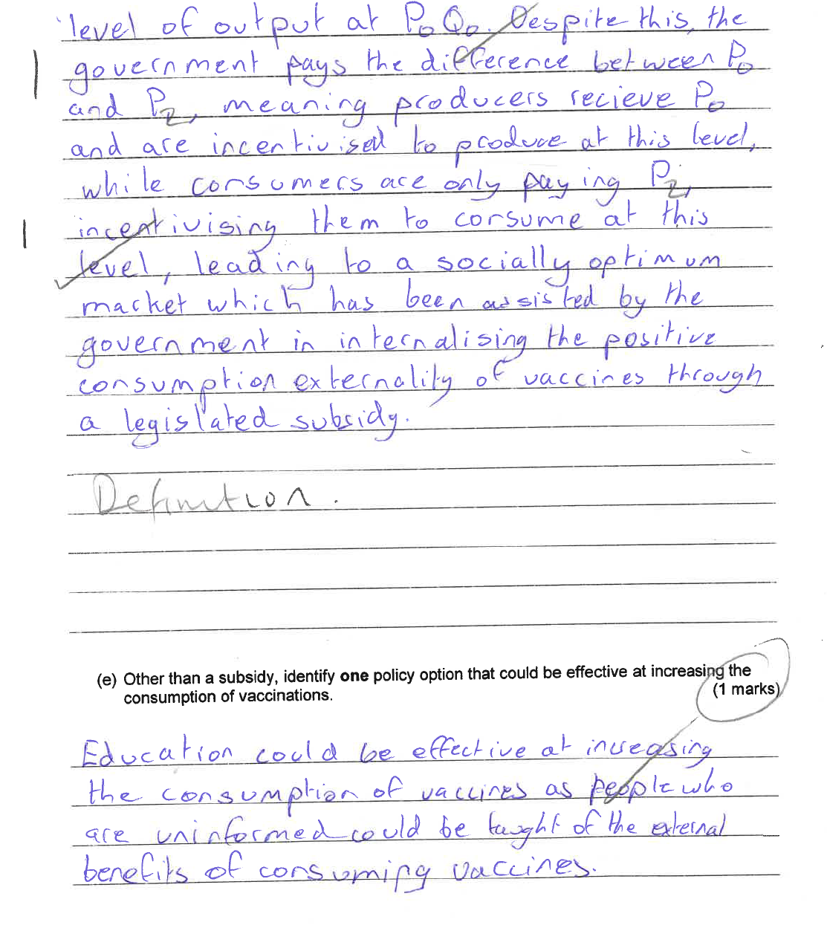

End of section 2

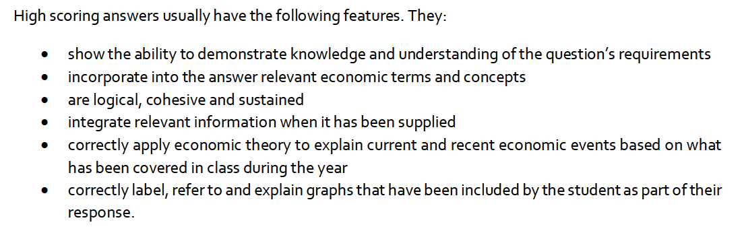
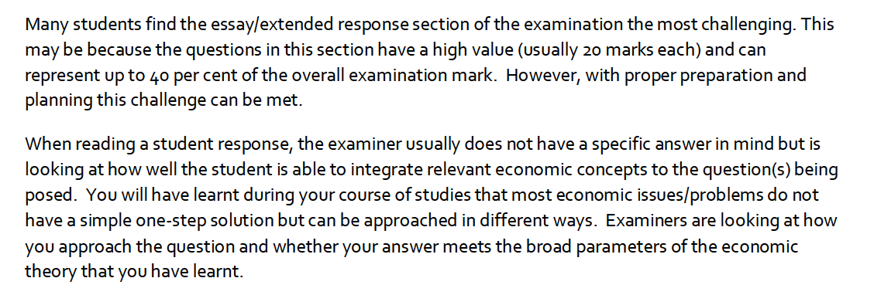
SECTION 3 40 marks (40%) – Answer TWO questions

RECAP - Directives and what they mean
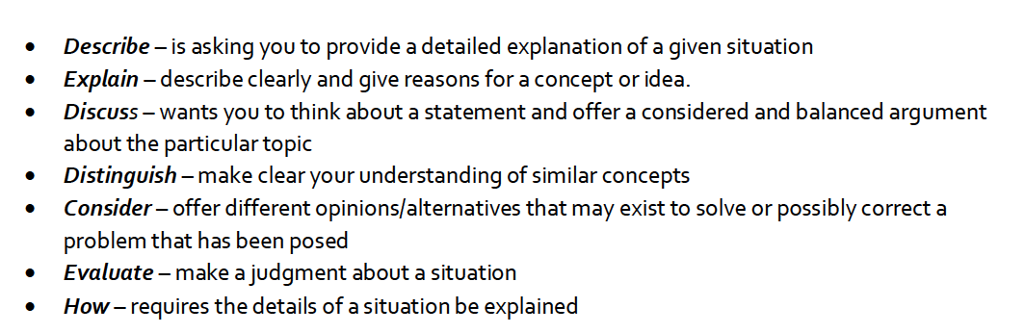
Suggested approach

STEP 1 – WHAT’S THE QUESTION ASKING
- Highlight key words
- Rewrite the question in your own words (either literally or in your head)
- What is the directive verb, what’s it asking you to do

STEP 2 – PLAN
- Short and succinct summary of what your going to include in each paragraph
- Intro – definitions; para’s – one point for each; models, conclusion – short and logical
- Must be logical
- Check no of paras against the marks allocation
- Quickly sketch models you're going to incorporate

STEP 3 - WRITE YOUR EA
- Stick to your pl
Question 28 (20 marks)

Comments:
- There was some confusion about the question. Characteristics of a market economy is not the same as characteristics of a competitive market.
- Level of explanation was lacking. (e.g explain what self interest means – not just from a consumer's perspective)
- Part (b), very few used a model, so key was adjusted to also reward 3 points explained.
- Part (c) was better. Minus half a mark if no example used.

- Describe three characteristics of a market economy.  - Private property  - Goods and services produced in the economy are largely owned by private individuals and private businesses rather than by government. E.g. Labour resources, natural resources, capital resources (e.g. equipment and buildings)  e.g. an individual owns a factory and the land where they produce output and employ people to work there.  - Freedom of enterprise and choice  - Private entrepreneurs are free to obtain and organize resources in the production of goods and services and to sell them in markets of their choices. E.g. sell fruit and veg at a market.  - Consumers can buy goods and services that best satisfies their economic wants. E.g. spend savings on a boat.  - Workers are free to seek any jobs for which they are qualified. E.g. train to be an accountant.  - Self-interest the "Invisible Hand" that is the driving force in a market economy is each individual promoting his or her self-interest.  - Consumers aim to get the greatest satisfaction from their budgets  - Entrepreneurs try to achieve the highest profits for their firms.  - Workers want the highest possible wages and salaries  - Owners of property resources attempt to get the highest possible prices from the rent and sale of their resources.  - Competition  - Economic rivalry means that buyers and sellers are free to enter or leave any market and that there are buyers and sellers acting independently in the marketplace. E.g. competitive firms aim to provide high quality products at competitive prices and consumers try to get the best price.  - System of market and prices  - A market brings buyers and sellers of a good or service into contact with one another. The preferences of sellers and buyers are registered on the supply and demand sides of various.  Limited Government Involvement  A competitive market economy promotes the efficient use of its resources. As a self-regulating and self-adjusting economy, no significant economic role for government is necessary. However, a number of limitations and undesirable outcomes associated with the market system result in an active, but limited economic role for government. | (6 marks)  Any 3  3 x 2 marks  Must PEE
- Explain the difference between competitive and non-competitive markets.  Draw a diagram to show a competitive or non-competitive market  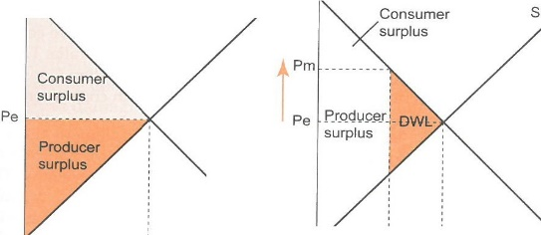  s  D  A competitive market is characterised by  - A large number of buyers and sellers  - Firms are price takers  - Very similar products  - Easy entry into the market  Must give an example  A Non-competitive market  - A small number of firms  - Product differentiation  - Firms are price setters  - Entry into the market is restricted  Must give an example | (6 marks)  Diagram  2 marks  OR  3 points explained  2 marks  (PEE)  2 marks  (PEE)
- Describe four barriers to entry into a market.  - Controlling a scarce resource Sole rights to produce something e.g. A diamond mine - until the late 1980's De Beers controlled 90% of the worlds diamond market.  - Government license granting a legal monopoly A legal monopoly offers a specific product or service at a regulated price. It can either be independently run and government regulated, or both government-run and government regulated. E.g. Australia post  - A technological advantage Gain a competitive advantage. e.g. Microsoft supplies the operating systems used in most computers.  - A patent the exclusive right granted by the government to an inventor to sell an invention for a certain number of years. (exclude others from making, using or selling it) (up to 17yrs in Australia)  - Extensive product differentiation Develop a competitive advantage, and a unique selling point. Can also be due to large scale advertising budget, controlling retail outlets. E.g. Myer/David Jones  - Economies of scale Economies of scale occur when the firm's production cost decrease as output increases. This usually occurs in large companies e.g. mining. It is hard for small companies to achieve economies of scale.  - Collusive behavior Firms collude to reduce competition in the market. E.g. price fixing. | (8 marks)  Any 4 x 2  (Must PEE)  Minus 0.5 if no example but good explaination
Sample Answer

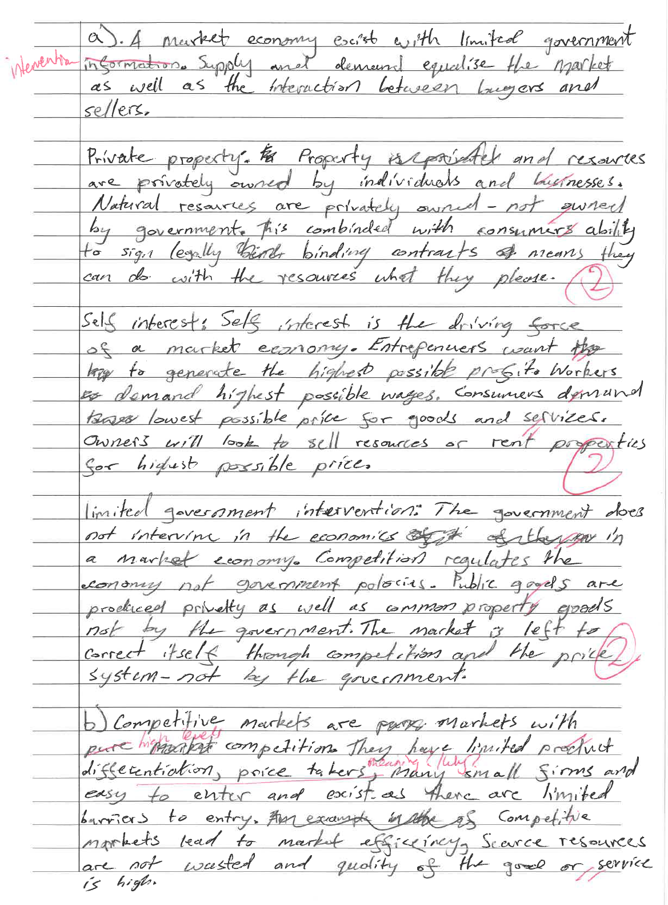

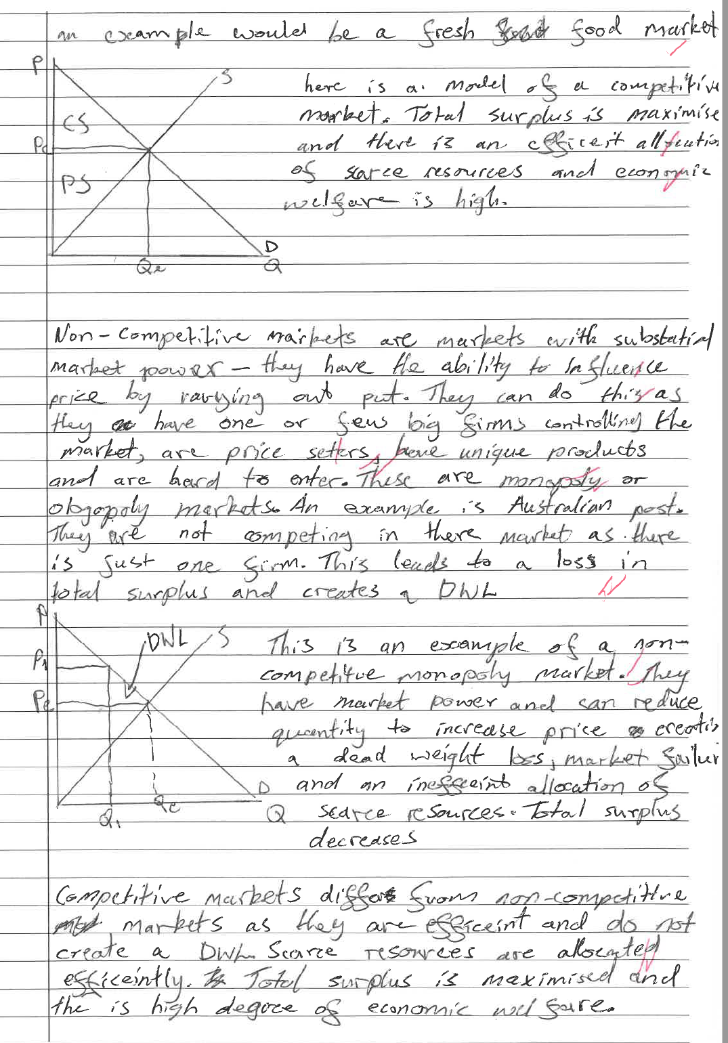
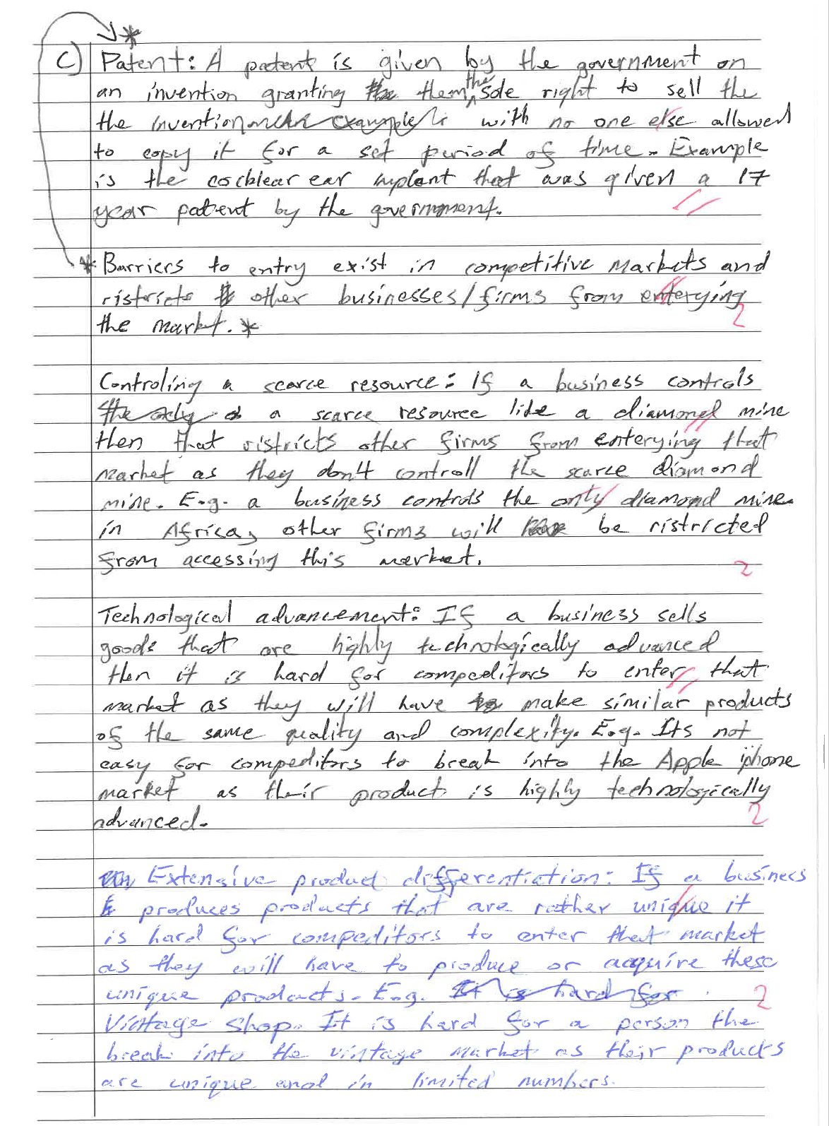
Question 29 (20 marks)

Comments

- Very poor in terms of detailed model. Arrow heads around the wrong way. Use of the term “profit” instead of “revenue”.
- Needed to give examples of factors of production
- Part (b) definition ok, but Law of Supply not fully supported by stating the “profit motive” of firms. Diagram not necessary if fully explained.
- Part (c) was better. Poor use of terminology (expansion), and also not fully referring to changes in the model. Cannot just state supply curve shifts, but must refer to changes in price and quantity.

- With the aid of a diagram outline the difference between product and factor markets  Ors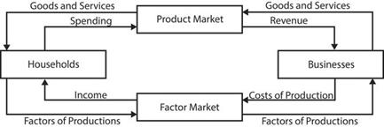  - product markets refer to the market for the final goods themselves (such as cars, clothes etc).  - Firms are sellers in the product market and HH are buyers  - Factor markets are concerned with markets for factors of production or inputs in a production process  - Households are sellers in the factor market and firms are buyers | (4 marks)  1 mark  diagram  1 mark  1/2 mark  1 mark  1/ 2 mark
- Define supply and explain the law of supply?  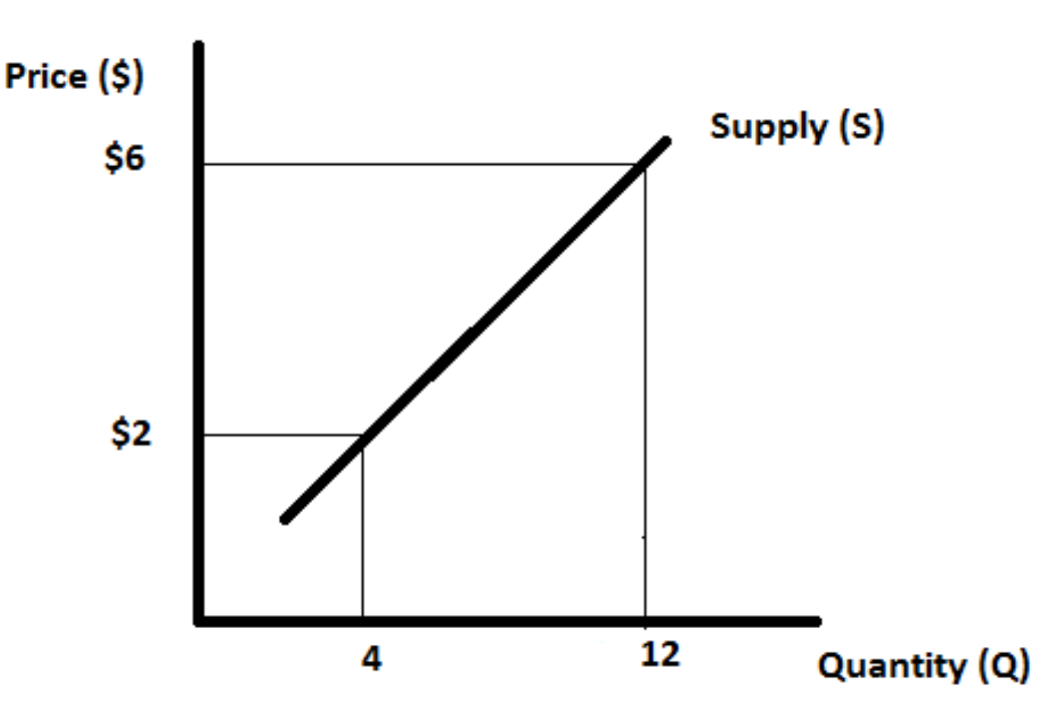  - Supply is the amount of a good or service that producers are willing and able to sell at a particular price and at a particular point in time.  - The law of supply states that ‘more will be supplied at higher prices, and less will be supplied at lower prices.’ (Ceteris Paribus)  - This is because producers would prefer to sell their output at a higher price than at a lower price because of the profit motive.  - The relationship between the quantity supplied and the price is a positive one. | (4 marks)  1 mark  1 mark  Diagram  OR  1 mark  1 mark  1 mark
- Illustrate and explain how each of the following would affect the market supply of a good:  An increase in the price of a good  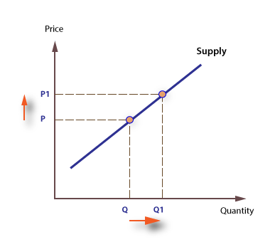  - The law of supply states the higher the price the higher the quantity will be produced. (profit motive)  - An increase in the price of the good will cause an EXPANSION along the supply curve. (P to P1) An increase in price will cause qty supplied to increase (Q to Q1)  An increase in input prices  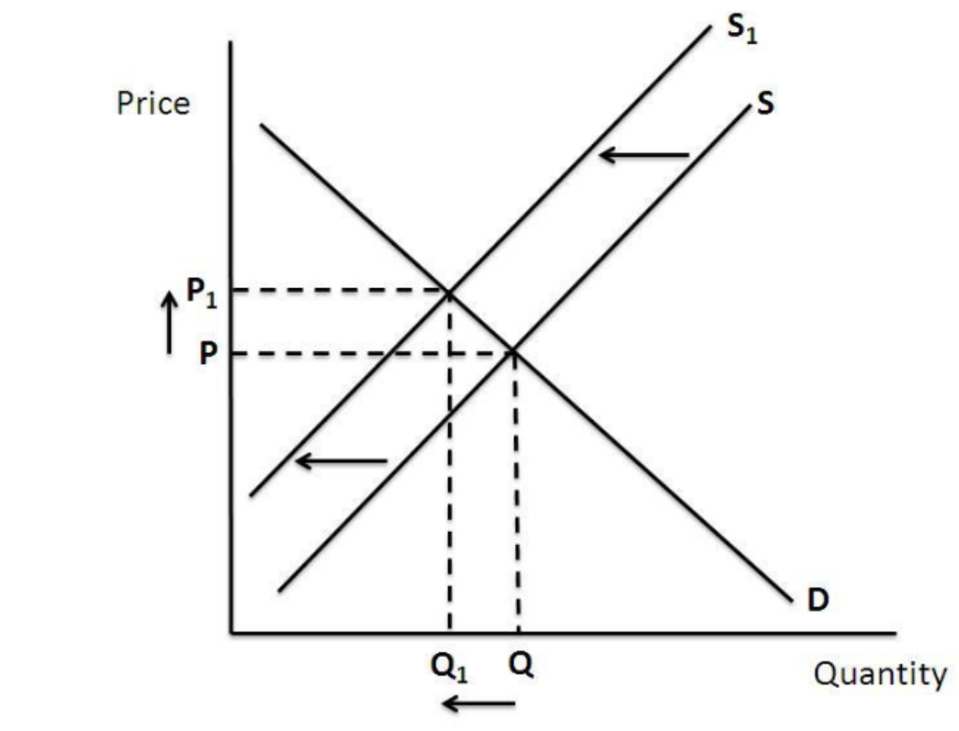  - The higher the cost of input prices will make it more expensive for producers to make their product, as a result they will decrease production levels.  - This will SHIFT the S curve to the left from S to S1. A new equilibrium is reached at a higher price and a lower quantity at P1Q1.  An improvement in technology  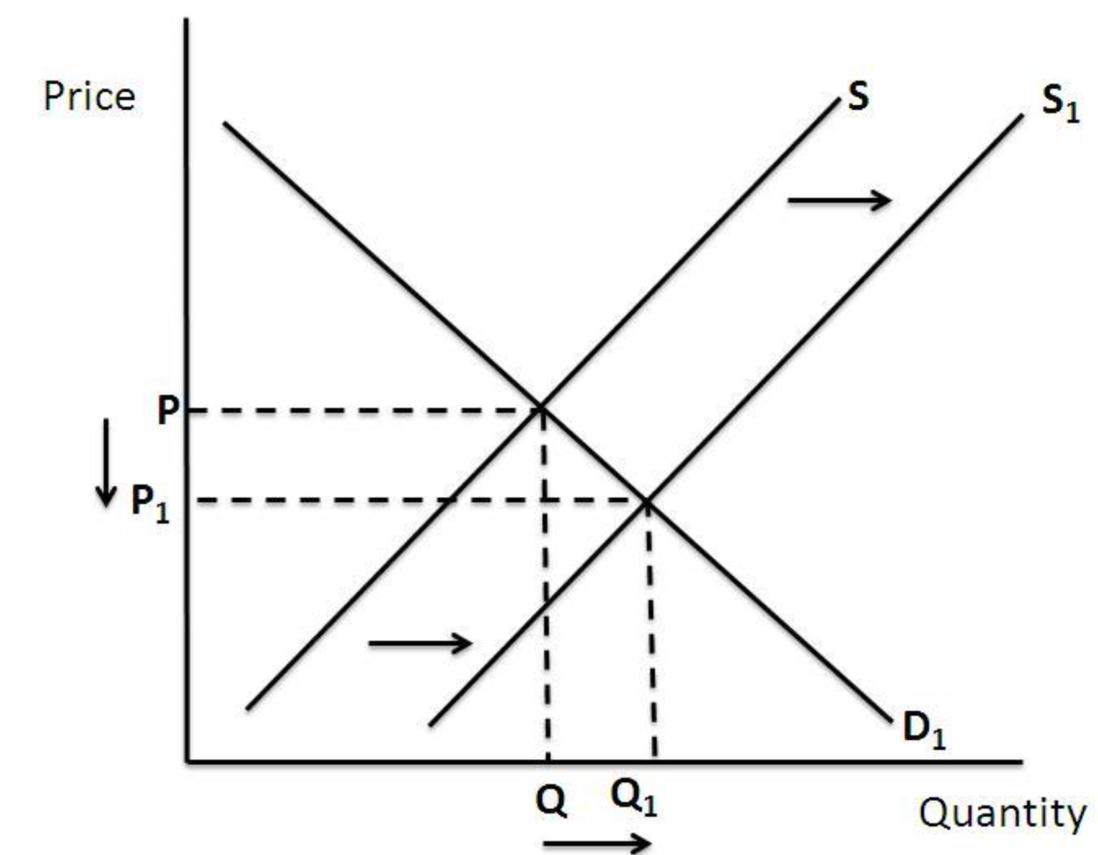  - An improvement in technology will cause supply to increase. This is because the firm can now produce more for the same price or less.  - This will SHIFT the S curve to the right from S to S1. A new equilibrium is reached at a lower price and a higher quantity at P1Q1.  An increase in the expected future price of the good  - If a higher price is expected in the future, then firms will decrease their current supply in order to take advantage of future higher prices.  - This will SHIFT the S curve to the left from S to S1. A new equilibrium is reached at a higher price and a lower quantity at P1Q1. | - arks)  3 marks x FOUR  factors  (2 for explanation; 1 for diagram)  1 mark  1 mark  1 mark  1 mark  1 mark  1 mark  1 mark  1 mark  1 mark

Sample Answer

See next page
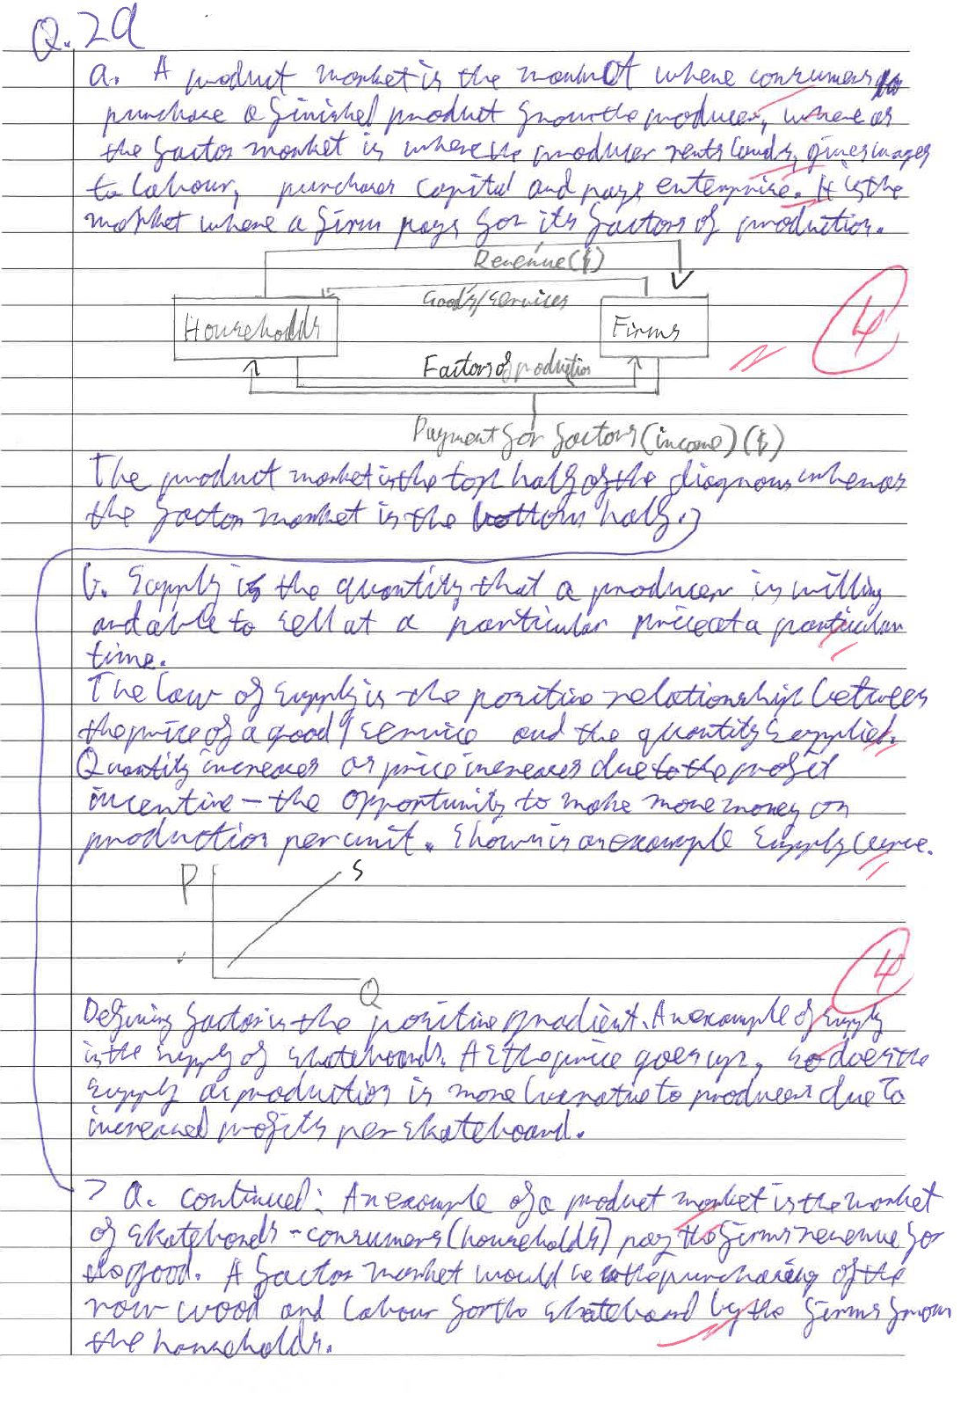

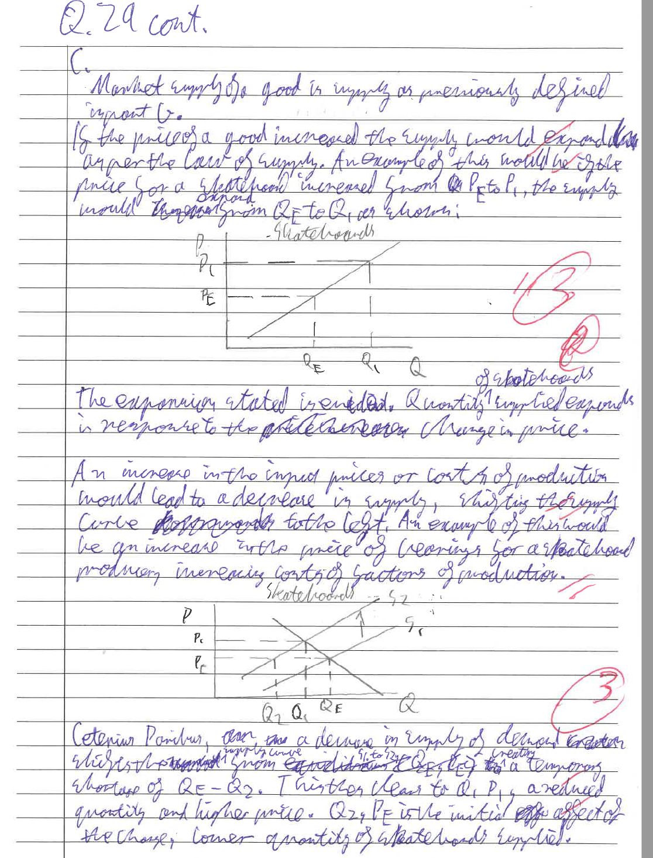

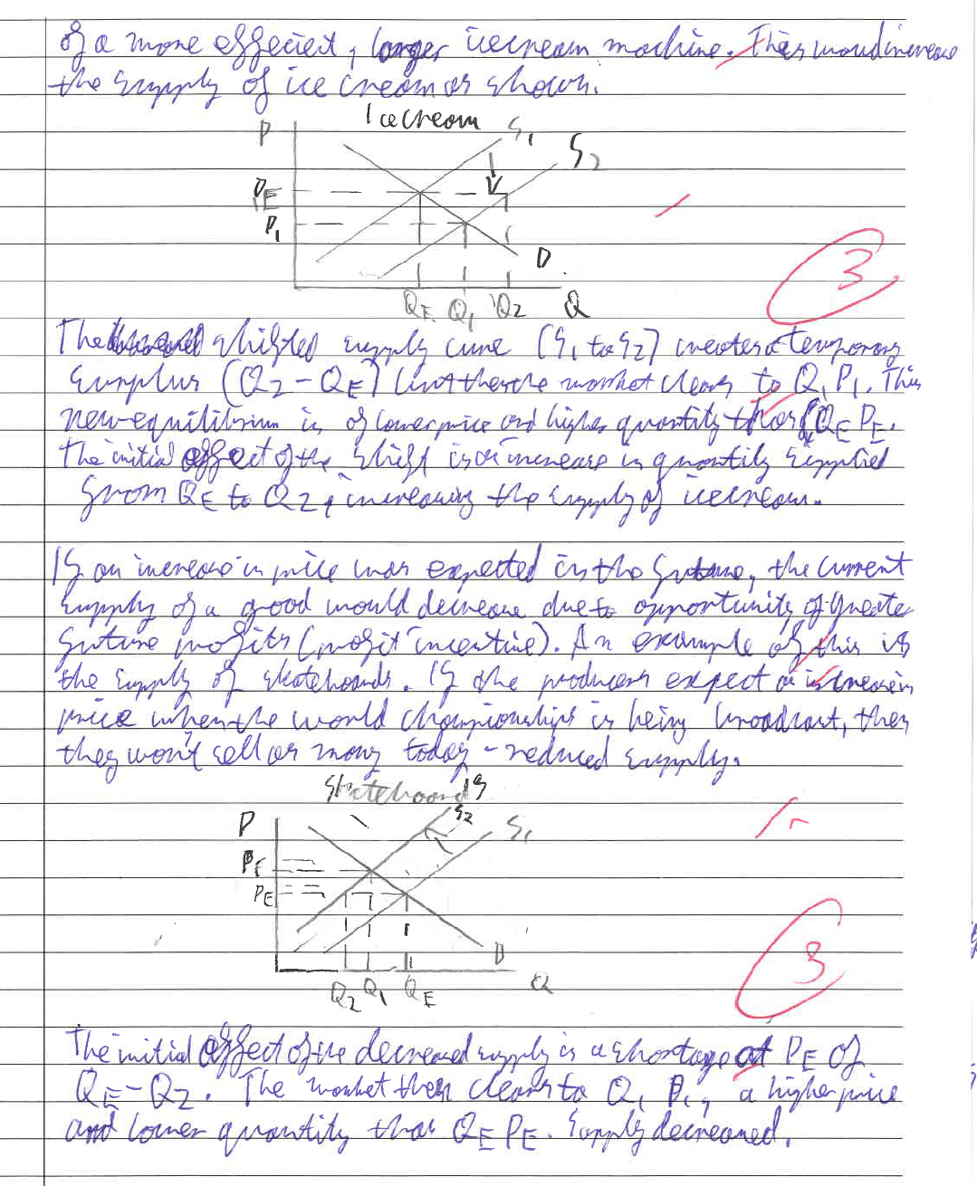

Question 30 (20 marks)

Comments

Part a)
- Students did not provide adequate explanation of the meaning of Es, simply gave a definition. Needed some elaboration for full 2 marks
- Responsiveness of supply to a change in price does not only refer to speed with which producers can respond. How responsive is what Es is measuring NOT how fast producers can react. e.g 1% rise in price 0.5% rise in S, means its inelastic, a 5% rise would make it elastic. In both cases they may be quick to respond.
- Many not providing examples of determinants.

Part b)
- Many students just repeating a description of the model for elastic and inelastic application of a tax. MUST read the question and carefully plan.
- Explanations and links to the models was poor
- Structure was also poor in many responses
- DWL not relevant to the question
- Many not discussing who the burden falls on (consumers or producers)

- Explain the meaning of price elasticity of supply and discuss three determinants of price elasticity of supply.  Explain – 2 marks  - Price elasticity of S is a measure of the responsiveness of supply (or qty supplied) to a change in price.  - e.g. If qty supplied increases by 2% after a 1% increase in price, then supply is said to be elastic.  1 mark for defn + 1 mark for elaboration  Determinants - 2 marks x THREE determinants  - Time: how much time producers have to respond to a change in price. In the short run S tends to be relatively inelastic; in the long run S becomes more elastic. E.g. supply of oil is relatively fixed, a known quantity of oil reserves. But over time businesses can respond to price rises with exploration and discovery of more reserves  - Nature of production: manufactured goods tend to have more elastic supply since producers can respond to a price change more readily; agricultural products tend to be relatively inelastic as they take time to produce  - Ability to store: if a producer can hold inventories in a warehouse then S will be relatively elastic e.g. non-perishable goods; perishable goods cannot be stored for long will be inelastic. | (8 marks)  1 mark  1 mark  3 x 2 mark  Must  PEE
- Using diagrams, explain the effect of imposing a tax on a good with elastic demand and a good with inelastic demand. Explain the impact on consumers, producers, and the government.  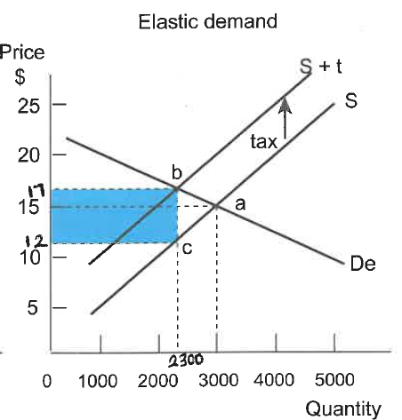  Taxing an elastic good  - Explanation of model - Before the tax price is $15 and the quantity is 3000. The tax causes the supply curve to shift by the amount of the tax. A $5 tax shifts the supply curve to S+ t. The after-tax price is $17 and the quantity is 2300. Consumers pay $17 and producers receive $12.  - Effects on producers and consumers – two main points  - Tax burden - The producer carry’s the tax burden. Of a $5 tax they pay $3. This is because consumers are very responsive to the price increase so will look for substitutes that are cheaper.  - PS falls by more than CS - Producer surplus and consumer surplus fall (as producers get lower prices $12 and receive lower revenue AND consumers must pay a higher price $17 and consume less) BUT PS falls by more than CS. Consumers only pay $2 of the $5 tax burden.  - Effect on Government - It is not effective to add a tax to elastic products as there will be less revenue raised for the government in comparison to taxing an inelastic good. Government receive the shaded area ($5 x 2300 =$1150)  Taxing an inelastic good  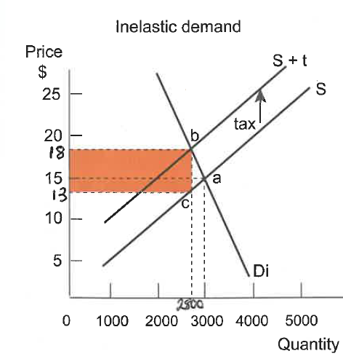  - Before the tax, price is $15 and quantity is 3000. The $5 tax shifts the supply curve to S + t. The after tax price is $18 and the quantity is 2800. Consumers pay $18 and producers receive $13.  - Effects on producers and consumers – two main points  - Tax burden - The consumer carry’s the tax burden. Of a $5 tax they pay $3. This is because consumers are not responsive to the price increase as there are little or no substitutes available.  - CS falls by more than PS - Producer surplus and consumer surplus fall (as producers get lower prices $13 and receive lower revenue AND consumers must pay a higher price $18 and consume less) BUT CS falls by more than PS. Producers only pay $2 of the $5 tax burden.  - Effect on government - There will be more revenue raised for the government in comparison to taxing an elastic good. (government revenue is shaded area $5 x 2800 =$14,000) | (12 marks)  2 marks  Diagram  1 - 4 marks  2 marks  Diagram  1 - 4 marks

Sample Answer

See next page

Part A

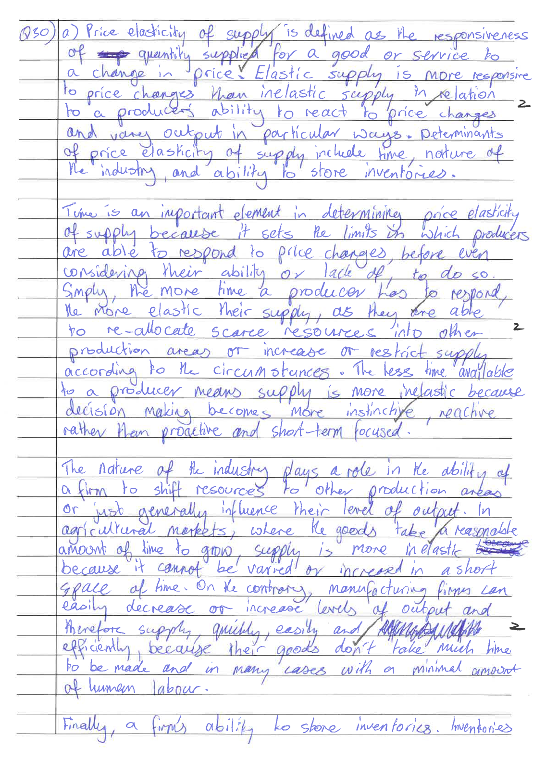

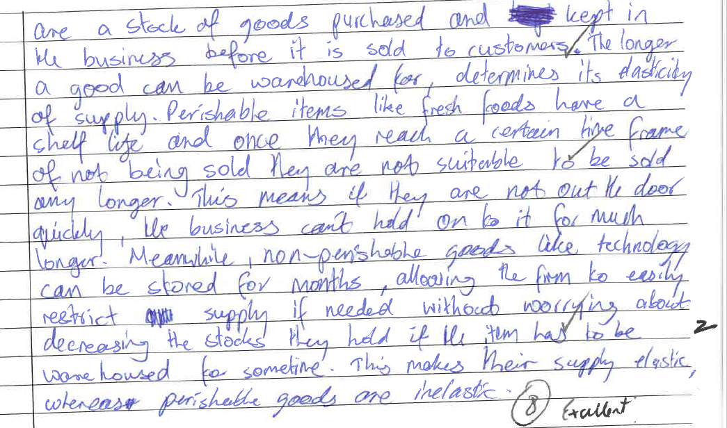

Part b

See next page
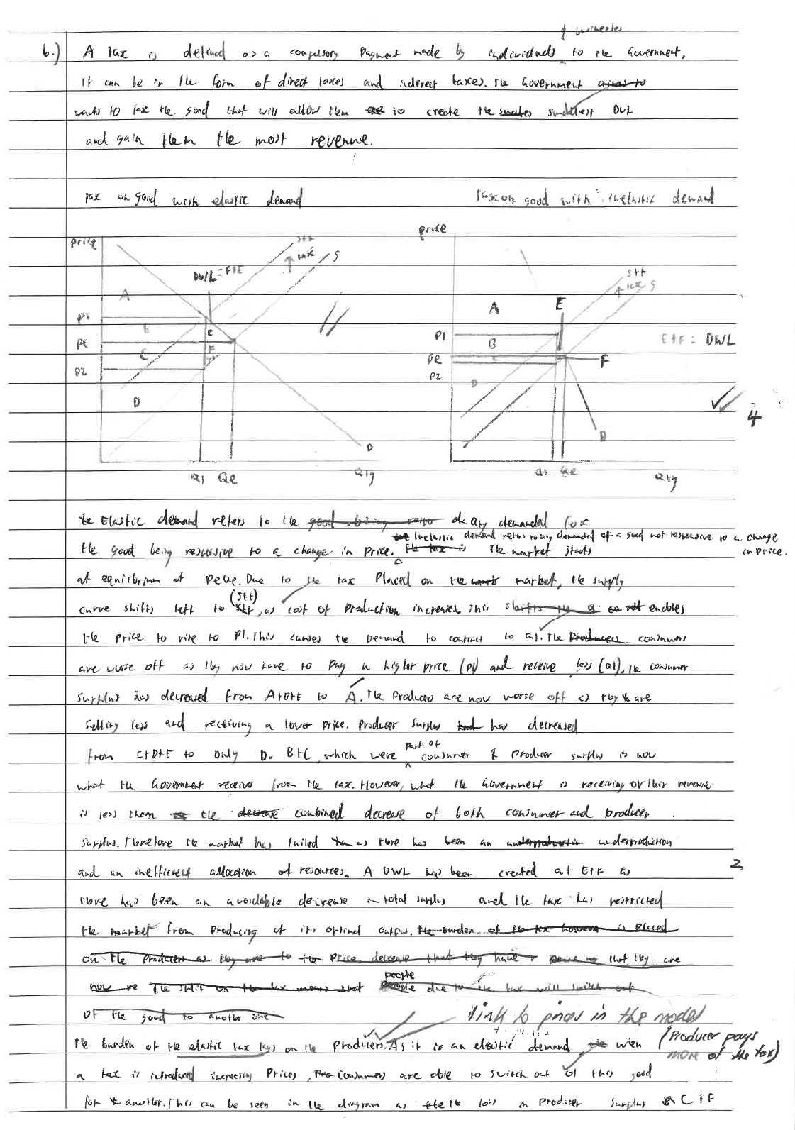
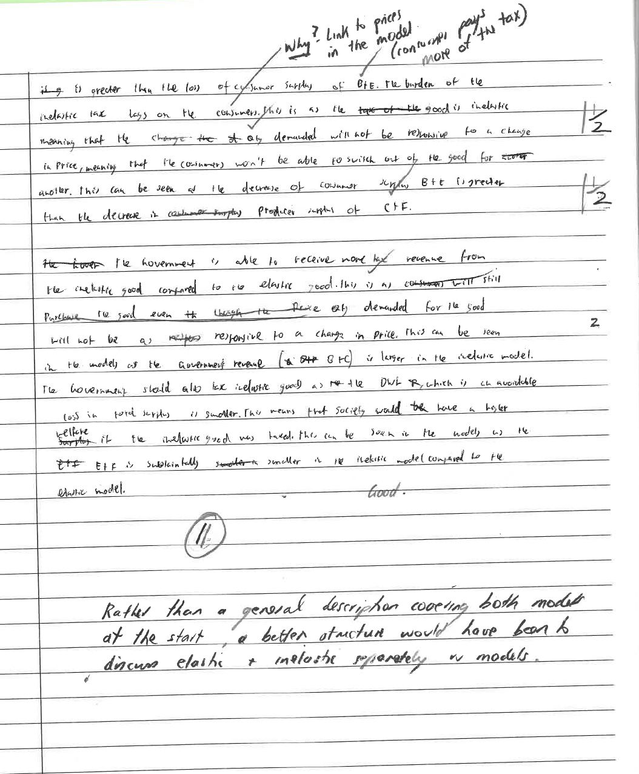

Question 31 (20 marks)

Comments

Part a)
- Many students stating the definition of CS and PS as consumers/producers willing and able to supply/demand. Incorrect definition
- Most students did not discuss the meaning of CS and PS i.e. measure of economic well being, maximizing economic welfare

Part b)
- Must explain ‘why’ : why CS decreases, why PS increases, why there’s a DWL
- Also need to discuss before and after to justify the effect of the Price floor

- Use a demand/supply model and the concepts of consumer and producer surplus to explain the benefits to both buyers and sellers from participating in a market.  - Definition CS represents the net benefit to a consumer from entering a market – it is the difference between what a consumer is willing to pay & what they actually pay.  - This is the area above the price line and below the demand curve  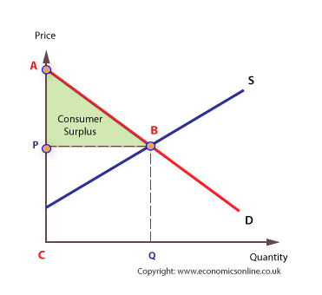  - It is a measure of the economic well-being for consumers. An increase in consumer surplus means that the consumer is better off and economic welfare has increased.  - Definition PS represents the net benefit to a producer from entering a market – it is the difference between what a producer is willing to receive & what they actually receive.  - This is the area below the price line and above the supply line.  It is a measure of the economic well-being for producers. An increase in producer surplus means that the producer is better off and economic welfare has increased  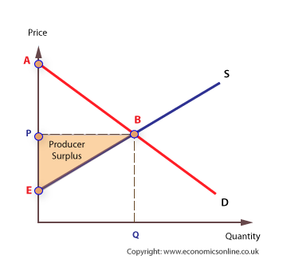 | (8 marks)  1 mark  1 mark  1 mark  1 mark  1 mark  1 mark  1 mark  1 mark
- Price floors are often used in agricultural markets. Explain the purpose of a price floor and with the aid of a model analyse its effects on consumers, producers and market efficiency.  - A price floor is a legislated minimum price set above the equilibrium price.  - It causes qty demanded to decrease (contract )& qty supplied to increase (expand), resulting in a surplus.  - Purpose – to raise incomes for agricultural producers &/or help stabilise prices  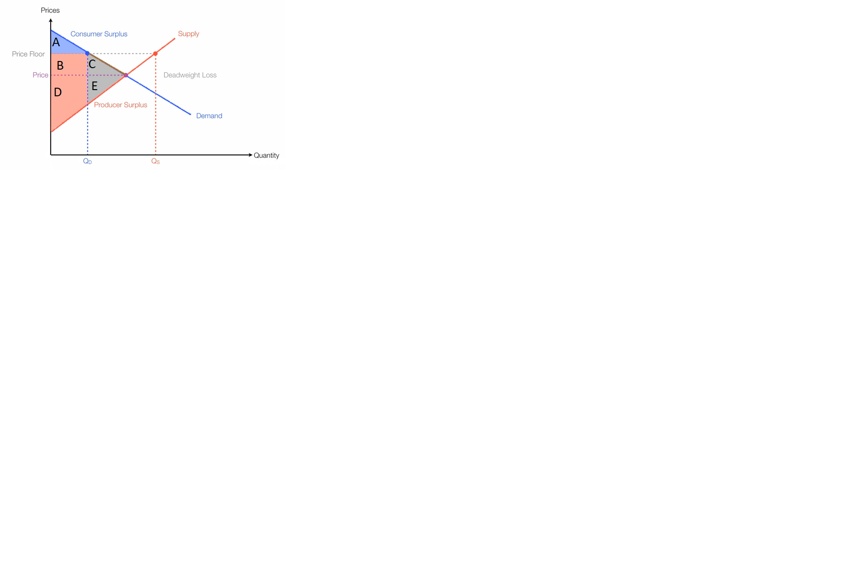  Must label CS, PS and DWL for 3 marks  - Effects on CS – will decrease because consumers have to pay a higher price & they consume less. This can be seen on the diagram; the original consumer surplus was A + B +C. After the PF is introduced the CS decreases to area A.  - Effects on PS – increases due to higher prices and increase in producer revenue. This can be seen on the diagram; PS before the PC was D + E. After the PC the PS increases to area B+D.  - Effect on market efficiency – the price floor reduces market efficiency because it causes a deadweight loss (DWL) – a decrease in total surplus. This can be seen in diagram in area C + E.  Must refer to model in answer to receive full marks | (12 marks)  1 mark  1 mark  1 mark  1-3 marks  Mark  1-2 marks  1-2 marks  1-2 marks

Sample Answer

See next page
